2.1 Networking 2

2.1.1 Add instances to load balancer
- Search “target groups”
- klik “Create target group”
- Basic configuration:
  - Choose a target type: Instances
  - Target group name: MyLabGroup
  - VPC: my-vpc (eigen keuze)
- Klik “next” en selecteer alle 5 EC2s
- Klik “Include as pending below”
- Klik “Create target group”

2.1.2 Create a Load Balancer
- Search “Load Balancers”
- Klik “Create load balancer”
- Load balancer types: Application Load Balancer - create
- Basic configuration:
  - Load balancer name: LabELB (eigen keuze)
- Network mapping:
  - VPC: my-vpc (ligt eraan wat meegegeven is)
  - Mappings: Alle 5 us-east-1 selecteren
- Security groups:
  - klik “create a new security group”
  - Security group name: 80 (eigen keuze)
  - Description: allow port 80 (eigen keuze)
  - VPC: my-vpc (ligt eraan wat meegeven is)
  - Outbound rules: type-HTTP (allows web port 80 traffic)
  - Klik “Create security group
- Listeners and routing:
  - Default action: Forwart to | MyLabGroup (ligt eraan wat meegegeven is)
- Klik “Create load balancer”

2.1.3 Test load balancers (verify)
- Klik de aangemaakte load balancer
- Kijk of State NIET OP Provisioning staat, maar
- Kopieer

2.2 databases

2.2.1 Create a database using PostgreSQL
- Search “RDS”
- Klik “Create database”
- Choose a database creation method: “Standard Create”
- Engine options: “PostgreSQL”
- Templates: Free tier
- Settings:
  - DB instance identifier: MyPostgresDB (eigen naam bedenken)
  - Master username: postgres (default laten zitten)
  - Credentials management: Self managed
  - Master password: “Pass1234”
- Connectivity: (Aanpassen wat gevraagd word)
  - Compute resource: Connect to an EC2 compute resource
  - EC2 instance: i-0c4a4d184614f0ae3 = pgadmin4 (in deze situatie)
- Klik “Create database”

2.2.2 Create a db connection in pgadmin4 - (Zie AWS_Database_foto)
- Lookup the public IP of the EC2 Instance – pgadmin4 (meegegeven) .
- Open “Public IPv4 address” in your browser
- log in to the pgadmin4 app with following credentials:
- User email: student@pxl.be
- Password: SuperSecret
- "add new server" and use the hostname, login&password you write down earlier for the database

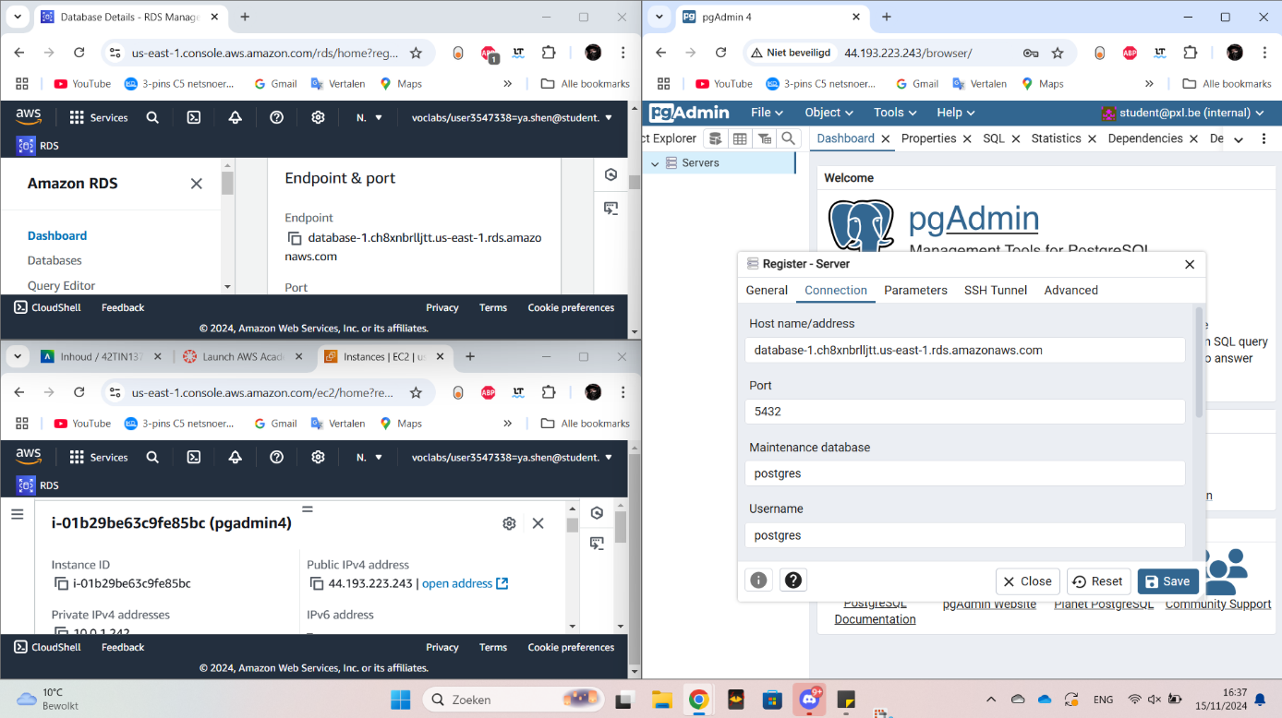

2.3 Lambda

Exercise 1
Create a Lambda Function: Write a Lambda function in Node.js that responds with "Hello, [Your Name]!" when invoked. Use the event object to allow the name to be passed in.

2.3.1 Create a lambda function
- Search “Lambda”
- Create function
- Basic Information:
  - Function name: LambdaTest (Zelf kiezen)
  - Runtime: Node.js 22.x
  - Change default execution role:
    - Existing role: LabRole (Is voor permissions)
- Klik “Create function”

2.3.2 Code source (name) – klaar:Deploy
export const handler = async (event) => {
// Extract the name property from the event object
const name = event.name;

// Construct the response message
const message = `greetings ${name}!`;

// Return the response
const response = {
statusCode: 200,
body: JSON.stringify(message),
};
return response;
};

Exercise 2
Write a Lambda function in Node.js that is triggered whenever a new file is uploaded to the S3 bucket. The Lambda function should log the file name and size of the uploaded file.

2.3.1 Create a S3 Bucket
- Search “S3”
- Bucket name: my-upload-bucket-10 (Moet uniek zijn)

2.3.2 Create lambda Function
- Search “Lambda” en “Create function”
- Basic information:
  - Function name: “S3UploadLogger” (meegegeven)
  - Runtime: Node.js 22.x
  - Change default execution role: Use an existing role
  - Existing role: LabRole
  - Klik “Create function”
- Voeg bij Code source:
import { S3 } from '@aws-sdk/client-s3';

console.log('Loading function');
const s3 = new S3();

export const handler = async (event) => {
console.log('Event received:', JSON.stringify(event, null, 2));

// Get the object from the event and show its content type
const bucket = event.Records[0].s3.bucket.name;
const key = decodeURIComponent(event.Records[0].s3.object.key.replace(/\+/g, ' '));
const params = {
Bucket: bucket,
Key: key,
};

try {
const ContentType = await s3.headObject(params);
// headObject() retrieves metadata (like file size) without downloading the file content
const fileSize = ContentType.ContentLength;
console.log(`File uploaded: ${key}, Size: ${fileSize} bytes`);

return {
statusCode: 200,
body: JSON.stringify({
message: `File uploaded: ${key}, Size: ${fileSize} bytes`,
}),
};
} catch (err) {
console.error(err);
const message = err.message;
console.error(message);
throw new Error(message);
}
};

export const handler = async (event) => {
for (const record of event.Records) {
const objectKey = decodeURIComponent(
record.s3.object.key.replace((/\+/g, ' '))
);
const objectSize = record.s3.object.size;

console.log(`File uploaded: ${objectKey}, Size: ${objectSize} bytes`);
}
};

2.3.3 Configure S3 Event Trigger
- Ga naar “Configuration” tab
- Kies “Triggers” en “Add trigger”
- Trigger configuration: S3
- Bucket: s3/my-upload-bucket-10 (my-upload-bucket-10)
- Event types: PUT
- “Recursive invocation” aanvinken

2.3.4 Test the function – CloudWatch (Logs groups)
- Search “S3”
- Klik jou aangemaakte bucket in deze situatie my-upload-bucket-10
- Klik op upload en voeg een lege file toe die je zelf aanmaakt
- Check in CloudWatch

Exercise 3
Build a Simple To-Do List API Using AWS Lambda and DynamoDB. To start off create a DynamoDB table called Todos with a primary key called id(string).
Code source for PUT:
import { DynamoDB } from '@aws-sdk/client-dynamodb';
import { DynamoDBDocument } from '@aws-sdk/lib-dynamodb';

const dynamo = DynamoDBDocument.from(new DynamoDB());

export const handler = async (event) => {
let body;
let statusCode = 200;

const headers = {
'Content-Type': 'application/json',
'Access-Control-Allow-Origin': '*',
};

try {
const item = JSON.parse(event.body);

console.log("Parsed item:", item);

const request = {
TableName: 'Todos',
Item: item,
};

console.log("Request for DynamoDB:", request);

await dynamo.put(request);

body = JSON.stringify({
message: 'Item added successfully',
item
});

} catch (err) {
console.error("ERROR:", err);

statusCode = 400;
body = JSON.stringify({ error: err.message });
}

return {
statusCode,
headers,
body
};
};

Code source for SCAN:
import { DynamoDB } from '@aws-sdk/client-dynamodb';
import { DynamoDBDocument } from '@aws-sdk/lib-dynamodb';

const dynamo = DynamoDBDocument.from(new DynamoDB());

export const handler = async () => {
let statusCode = 200;
let body;

const headers = {
'Content-Type': 'application/json',
'Access-Control-Allow-Origin': '*',
};

try {
const params = {
TableName: 'Todos',
};

// Scan the DynamoDB table
const result = await dynamo.scan(params);

console.log('All Todo Items:', result.Items);

body = JSON.stringify({
message: 'Todos retrieved successfully',
items: result.Items,
});

} catch (err) {
console.error('ERROR:', err);

statusCode = 500;
body = JSON.stringify({ error: err.message });
}

return {
statusCode,
headers,
body,
};
};

Exercise4
- Create EC2 instance

2.4 API Gateway

Exercise 1
New AWS API gateway resource and method (GET) returning a simple static message in response to an HTTP request

2.4.1 Create API Gateway
- Search “Api Gateway”
- “Build” a REST API
- API details: New API
- API name: simple_static_message (meegegeven)
- Klik “Create API”

2.4.2 Create resource
- Klik bij Resources “Create resource”
- Geef bij Resource name “simple_static_message” (meegegeven)
- Klik “Create source”

2.4.3 Create method – GET
- Selecteer de aangemaakt “/simple_static_message” en klik op “Create method”
- Hier gaan we alleen een response naar HTTP request returnen (GET) – Method type
- We gebruiken Integration type “Mock”
- Klik “Create method”

2.4.4 Adding GET – Integration response – Mapping templates (template body)
- Selecteer “GET” die je hebt aangemaakt in de Resources
- Ga naar “Integration response”
- Klik “Edit” en scroll naar beneden tot “Mapping templates”
- Voeg code in de “template body”:
  - {“message”: “Hello, World!”}
- Selecteer opnieuw “/simple_static_message” en klik op “Enable CORS”
- Access-Control-Allow-Methods: GET
- “Additional settings – Access-Control-Allow-Credentials” aanvinken
- Klik “save”

2.4.5 Deploying API
- Klik “Deploy API”
- Stage: *New stage*
- Stage name: dev (meegegeven)

2.4.6 Invoke URL – GET
- Ga naar “Stages” en kopieer de “Invoke URL” van de root “GET” – je moet het de mappen uitklappen

Exercise 3
Create a Lambda function that processes a request and returns a greeting message based on a users input. Create a POST method in API Gateway that triggers a Lambda function.

2.4.7 Create Lambda function – Node.js 22.x
- Search “Lambda” en “Create function”
- Basic information:
  - Function name: “GreetingFunction” (meegegeven)
  - Runtime: Node.js 22.x
  - Change default execution role: Use an existing role
  - Existing role: LabRole
  - Klik “Create function”
- Voeg bij Code source:
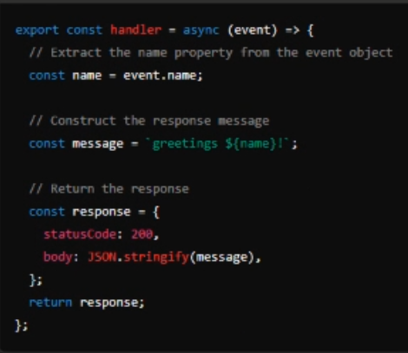
- Klik “Deploy (Ctrl+Shift+U)”

2.4.8 Create API Gateway
- Search “Api Gateway”
- Klik “Create API”
- “Build” a REST API
- API details: New API
- API name: GreetingAPI (meegegeven)
- Klik “Create API”

- Klik bij Resources “Create resource”
- Geef bij Resource name “greet” (meegegeven)
- Vinkaan CORS (Cross Origin Resource Sharing)
- Klik “Create source”

- Selecteer de aangemaakt “/greet” en klik op “Create method”
- Hier gaan we request processen en geeft een greeting message gebaseerd op de users input (POST) – Method type
- We gebruiken Integration type “Lambda function”
- Lambda function ga je bij us-east-1 “arn:aws:….:function:GreetingFunction” die we hadden aangemaakt bij lambda
- Klik “Create method”

- Deploy API – gebruik Postman – Kopieer Invoke URL van POST in Stages
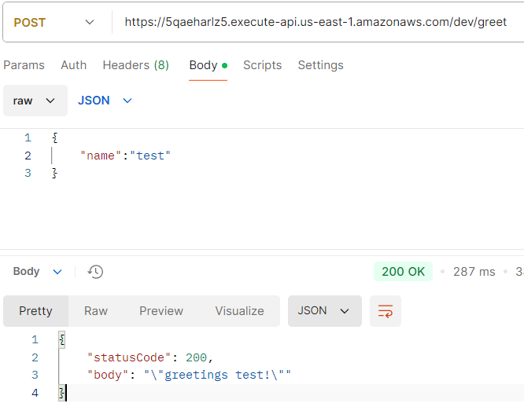

Excercise 4
Follow the tutorial on https://docs.aws.amazon.com/apigateway/latest/developerguide/http-api-dynamo-db.html to create an API gateway that uses lambda functions to interact with a DynamoDB table (steps 1-8).
Create a DynamoDB table
- Search “DynamoDB”
- Choose Create table.
- For Table name, enter http-crud-tutorial-items.
- For Partition key, enter id.
- Choose Create table.

Create a lambda function
- Search “Lambda” en “Create function”
- Basic information:
  - Function name: “GreetingFunction” (meegegeven)
  - Runtime: Node.js 22.x
  - Change default execution role: Use an existing role
  - Existing role: LabRole
  - Klik “Create function”
- Voeg bij Code source:
import { DynamoDBClient } from "@aws-sdk/client-dynamodb";
import {
DynamoDBDocumentClient,
ScanCommand,
PutCommand,
GetCommand,
DeleteCommand,
} from "@aws-sdk/lib-dynamodb";

const client = new DynamoDBClient({});

const dynamo = DynamoDBDocumentClient.from(client);

const tableName = "http-crud-tutorial-items";

export const handler = async (event, context) => {
let body;
let statusCode = 200;
const headers = {
"Content-Type": "application/json",
};

try {
switch (event.routeKey) {
case "DELETE /items/{id}":
await dynamo.send(
new DeleteCommand({
TableName: tableName,
Key: {
id: event.pathParameters.id,
},
})
);
body = `Deleted item ${event.pathParameters.id}`;
break;
case "GET /items/{id}":
body = await dynamo.send(
new GetCommand({
TableName: tableName,
Key: {
id: event.pathParameters.id,
},
})
);
body = body.Item;
break;
case "GET /items":
body = await dynamo.send(
new ScanCommand({ TableName: tableName })
);
body = body.Items;
break;
case "PUT /items":
let requestJSON = JSON.parse(event.body);
await dynamo.send(
new PutCommand({
TableName: tableName,
Item: {
id: requestJSON.id,
price: requestJSON.price,
name: requestJSON.name,
},
})
);
body = `Put item ${requestJSON.id}`;
break;
default:
throw new Error(`Unsupported route: "${event.routeKey}"`);
}
} catch (err) {
statusCode = 400;
body = err.message;
} finally {
body = JSON.stringify(body);
}

return {
statusCode,
body,
headers,
};
};
- Deploy the source

Create an HTTP API
- Search “API Gateway”
- Choose Create API, and then for HTTP API, choose Build.
- For API name, enter http-crud-tutorial-api.
- Choose Next.
- For Configure routes, choose Next to skip route creation. You create routes later.
- Review the stage that API Gateway creates for you, and then choose Next.
- Choose Create.

Create routes
- GET /items/{id}
- GET /items
- PUT /items
- DELETE /items/{id}

Create an integration
- Search “API Gateway”
- Choose your API.
- Choose Integrations.
- Choose Manage integrations and then choose Create.
- “Attack this integration to a route” – all 4 of them
- For Integration type, choose Lambda function.
- For Lambda function, enter http-crud-tutorial-function.
- Choose Create.

Test you API - POSTMAN
- Search “API gateway”
- Zoek “Deploy” – Stages en kopieer “Invoke URL”
URL | PUT /items | GET /items | GET /items/{id} | Delete /item
Body | {  "id":"123",  "price": "12345",  "name": "myitems"  } | / | /
send | “Put item 123” | [  {  "price": "12345",  "id": "123",  "name": "myitems"  }  ] | {  "price": "12345",  "id": "123",  "name": "myitems"  } | “Deleted item 123”

Exercise 5:
- Idem als gewone HTTP API gateway, routes en intergrations
- WEL: CORS enablen:

